ENISA says goodbye to Prof. Dr. Udo Helmbrecht after 10 years in Office

If the EU Agency for Cybersecurity has developed into the successful entity it is today, it is essentially thanks to the leadership of its Executive Director, Prof. Dr. Udo Helmbrecht.

Published on October 15, 2019

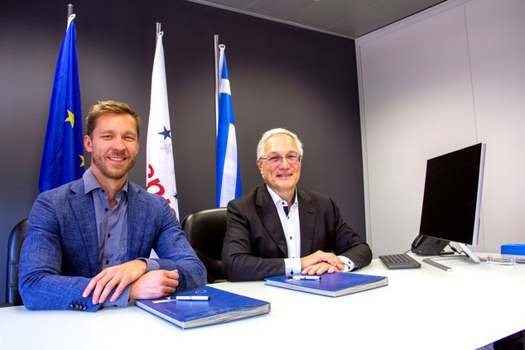

Tagged with

* [Management Board (MB)](https://www.enisa.europa.eu/search?Subject%3Alist=Management%20Board%20%28MB%29)
* [ENISA](https://www.enisa.europa.eu/search?Subject%3Alist=ENISA)
* [Management Board](https://www.enisa.europa.eu/search?Subject%3Alist=Management%20Board)
* [Udo Helmbrecht](https://www.enisa.europa.eu/search?Subject%3Alist=Udo%20Helmbrecht)
* [ENISA's Role](https://www.enisa.europa.eu/search?Subject%3Alist=ENISA%27s%20Role)
* [cybersecurity](https://www.enisa.europa.eu/search?Subject%3Alist=cybersecurity)
* [Executive Board](https://www.enisa.europa.eu/search?Subject%3Alist=Executive%20Board)

He was appointed to the role of Executive Director by the Management Board of ENISA in 2009, which was renewed in 2014 for an additional 5 years.

Our Executive Director will be remembered in the history of ENISA for the exceptional milestones he leaves behind. At a time when the future of the Agency was still doubtful, he managed to secure the last two essential extensions of the mandate, this last one making the Agency permanent. Last but certainly not least, he achieved the conclusion of the Cybersecurity Act with the opportunity to introduce the first European Cybersecurity Certification Scheme and strengthening the role of the Agency.

Udo handed over his duties to his successor, Mr. Juhan Lepassaar who will start his 5-year term tomorrow, 16th October 2019.

Today, Udo attended his last Management Board of ENISA Meeting, which includes the election of the Chairperson and the Deputy Chairperson. We would like to congratulate Mr Jean-Baptiste Demaison from ANSSI (France) on his re-election as Chairperson and Mr Krzysztof Silicki of NASK (Poland) on his re-election as Deputy Chairperson.

Thus turning a new page of ENISA’s history today, we, the staff of ENISA, would like to express our gratefulness to Udo, the man who committed to the Agency and thank him for transforming ENISA into the mature organisation it has now become.

We would like to wish him the best in his new endeavours and we hope he will remember us as fondly as we will remember him.